FUNCTIONAL PROGRAMMING LAB TEST - I

20PW34

7/22/2024

import Data.List (partition, intersect)

import Text.Printf

numberOfDigits = 4 :: Int

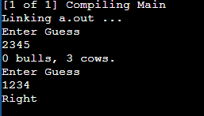main :: IO ()

main = do

let secret_code = "1234"

loop secret_code

where loop secret_code = do

putStrLn "Enter Guess"

input <- getLine

let (bulls, cows) = score secret_code input in

if bulls == numberOfDigits then

putStrLn "Right"

else do

printf "%d bulls, %d cows.\n" bulls cows

loop secret_code

score :: String -> String -> (Int, Int)

score secret guess = (length bulls, cows)

where (bulls, nonbulls) = partition (uncurry (==)) $ zip secret guess

cows = length $ uncurry intersect $ unzip nonbulls